CMPG 325 Technical Report: Kgalagadi Transport Solutions (Klerksdorp)
Student: MANAGA, WW | Student number: 44835507 | Project ID: CMPG325-2026-044 | Client ID: CLI-044
Assigned challenge: IPv6 (dual-stack addressing and routing) | Constraint: CCTV traffic segmented from office data traffic | Change request: CR15, a second Internet connection | Addressing block: 10.24.0.0/16

1. Introduction and client background
Kgalagadi Transport Solutions is a logistics company in Klerksdorp that moves goods for its customers and depends on its network for daily office work, depot operations and security monitoring. The network must connect the Office and Logistics staff, a company server and the CCTV cameras, and give them reliable Internet access. I designed and built it in Cisco Packet Tracer using the 10.24.0.0/16 address block. The project has three tasks. The first is IPv6 dual-stack addressing and routing, so every VLAN and router link runs IPv4 and IPv6 together. The second is CCTV segmentation, so the cameras are kept apart from office data traffic. The third is change request CR15, which adds a second Internet connection through Router2 and ISP2 so the company keeps Internet access if the primary path fails.

2. Requirements and constraints
Item | Requirement from the brief
Tool | Cisco Packet Tracer
Addressing | Use 10.24.0.0/16 as the basis of the IP plan
Assigned challenge | Configure, verify and demonstrate IPv6 (dual-stack addressing and routing)
Design constraint | CCTV traffic must be segmented from office data traffic
Change request | CR15: a second Internet connection is added for resilience and must be integrated
Testing | End-to-end connectivity, verification of the challenge, evidence, troubleshooting documented, .pkt reopens and works

3. Network design and topology
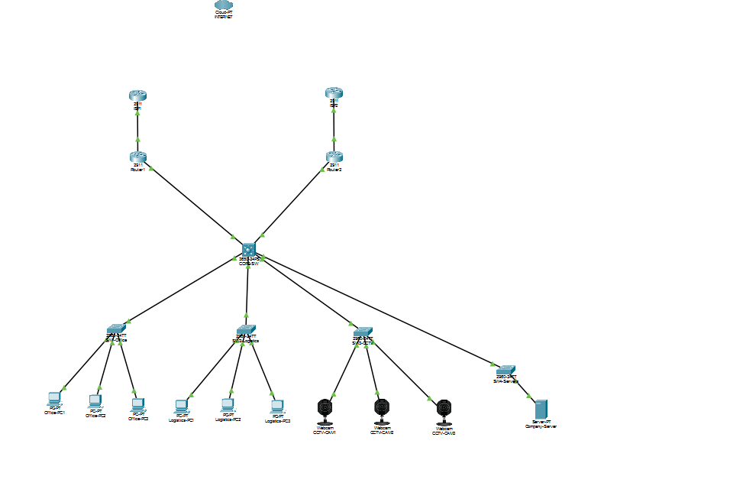
Figure 1: Network topology after cabling Router1, Router2, ISP1 and ISP2
Device | Role
CORE-SW (multilayer switch) | Inter-VLAN routing for IPv4 and IPv6, default routes towards both routers, CCTV ACLs
SW1-Office, SW2-Logistics, SW3-CCTV, SW4-Servers | Access switches for the four VLANs
Router1 (R1) | Primary Internet edge, connected to ISP1
Router2 (R2) | Backup Internet edge, connected to ISP2 (CR15)
ISP1, ISP2 | Simulated Internet providers
Office-PC1 to 3, Logistics-PC1 to 3 | User PCs
CCTV-CAM1 to 3 | Cameras on the CCTV VLAN
Company-Server | Server on the server VLAN

I used a multilayer core switch because it routes between VLANs at high speed inside the LAN, so no router is needed for local traffic. I used two routers because Router2 gives a backup Internet path for CR15, so the network survives if Router1 or its link fails. I used four VLANs to separate Office, Logistics, CCTV and Server traffic. This gives better security and control, and it makes the CCTV constraint possible.

4. IP addressing plan

4.1 VLANs and subnets
VLAN | Purpose | IPv4 subnet | IPv4 gateway (CORE-SW) | IPv6 prefix | IPv6 gateway (CORE-SW)
10 | Office | 10.24.10.0/24 | 10.24.10.1 | 2001:DB8:24:10::/64 | 2001:DB8:24:10::1
20 | Logistics | 10.24.20.0/24 | 10.24.20.1 | 2001:DB8:24:20::/64 | 2001:DB8:24:20::1
30 | CCTV | 10.24.30.0/24 | 10.24.30.1 | 2001:DB8:24:30::/64 | 2001:DB8:24:30::1
40 | Servers | 10.24.40.0/24 | 10.24.40.1 | 2001:DB8:24:40::/64 | 2001:DB8:24:40::1

4.2 Router links
Link | Side A | Side B
CORE-SW Gi1/0/5 to Router1 Gi0/0 | CORE-SW 10.24.254.1/30 and 2001:DB8:24:F1::1/64 | R1 10.24.254.2/30 and 2001:DB8:24:F1::2/64
CORE-SW Gi1/0/6 to Router2 Gi0/0 | CORE-SW 10.24.254.5/30 and 2001:DB8:24:F2::1/64 | R2 10.24.254.6/30 and 2001:DB8:24:F2::2/64
Router1 Gi0/1 to ISP1 | R1 203.0.113.1/30 and 2001:DB8:FF:1::1/64 | ISP1 203.0.113.2 and 2001:DB8:FF:1::2
Router2 Gi0/1 to ISP2 | R2 203.0.113.5/30 and 2001:DB8:FF:2::1/64 | ISP2 203.0.113.6/30 and 2001:DB8:FF:2::2/64

4.3 Hosts I configured and tested
Host | VLAN | IPv4 | IPv6 | Gateways
Office-PC1 | 10 | 10.24.10.10 | 2001:DB8:24:10::10 | 10.24.10.1 and 2001:DB8:24:10::1
Company-Server | 40 | 10.24.40.10 | 2001:DB8:24:40::10 | 10.24.40.1 and 2001:DB8:24:40::1
CCTV-CAM1 | 30 | 10.24.30.10 | 2001:DB8:24:30::10 | 10.24.30.1 and 2001:DB8:24:30::1
CCTV-CAM2 | 30 | 10.24.30.11 | 2001:DB8:24:30::11 | same
CCTV-CAM3 | 30 | 10.24.30.12 | 2001:DB8:24:30::12 | same
Office-PC2 | 10 | 10.24.10.11 | 2001:DB8:24:10::11 | 10.24.10.1 and 2001:DB8:24:10::1
Logistics-PC1 | 20 | 10.24.20.10 | 2001:DB8:24:20::10 | 10.24.20.1 and 2001:DB8:24:20::1
Logistics-PC2 | 20 | 10.24.20.11 | 2001:DB8:24:20::11 | 10.24.20.1 and 2001:DB8:24:20::1
Logistics-PC3 | 20 | 10.24.20.12 | 2001:DB8:24:20::12 | 10.24.20.1 and 2001:DB8:24:20::1
Office-PC3 | 10 | 10.24.10.12 | 2001:DB8:24:10::12 | 10.24.10.1 and 2001:DB8:24:10::1
Internet test addresses used on the ISP side: 8.8.8.8 and 2001:db8:8888::1.
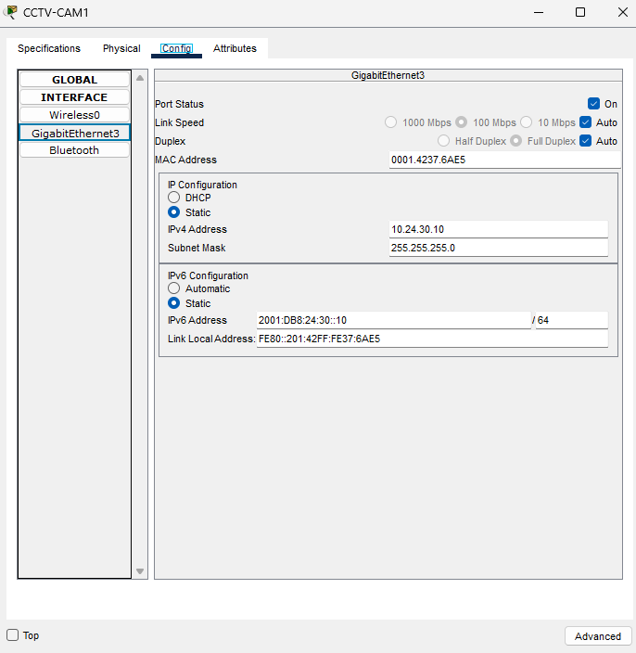
Figure 2: CCTV-CAM1 IP configuration
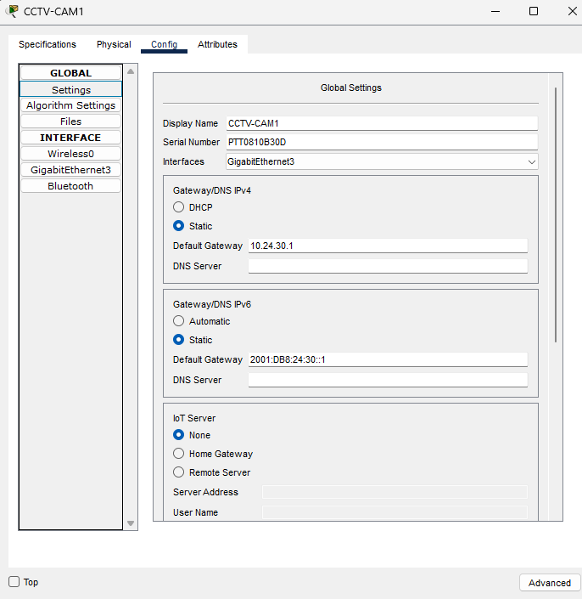
Figure 3: CCTV-CAM1 static gateways
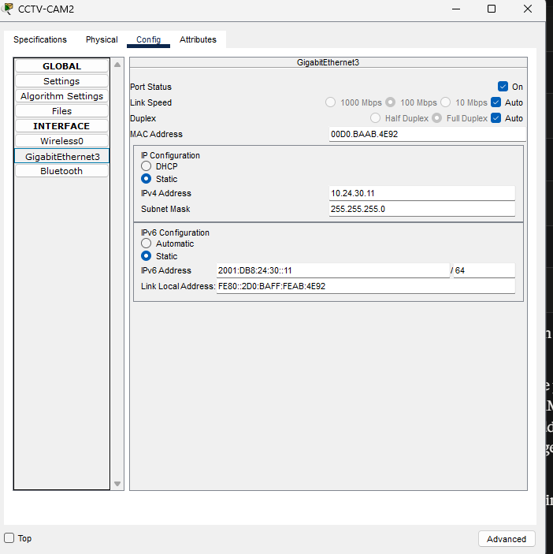
Figure 4: CCTV-CAM2 IP configuration
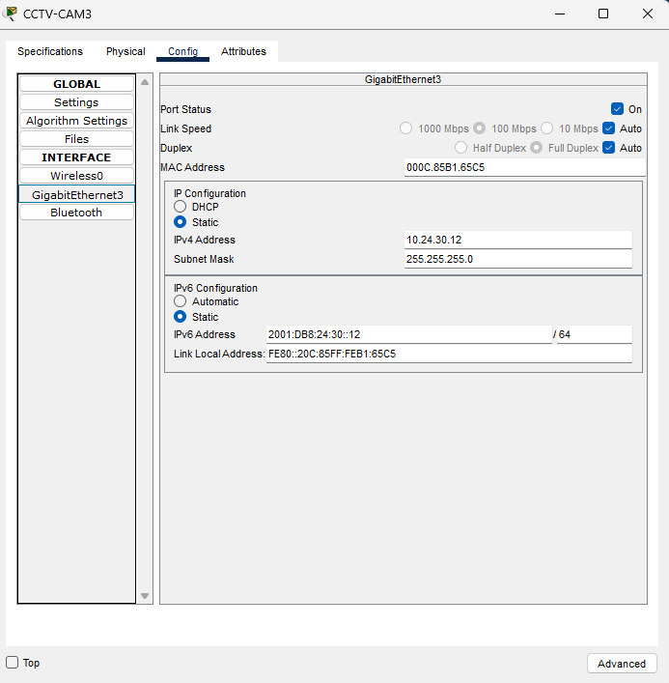
Figure 5: CCTV-CAM3 IP configuration
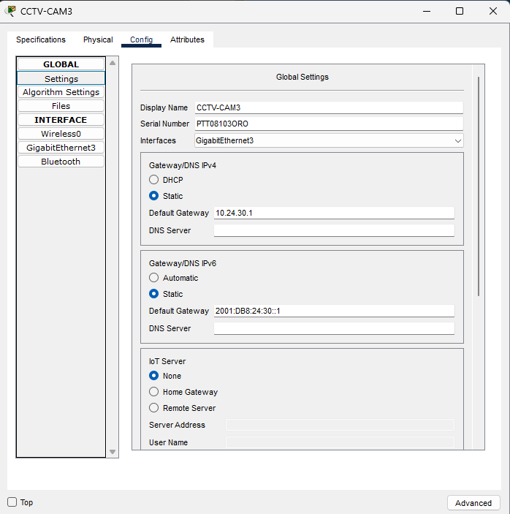
Figure 6: CCTV-CAM3 static gateways
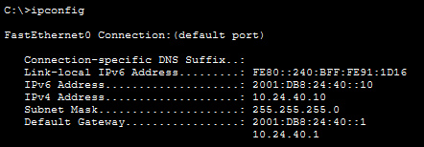
Figure 7: Company-Server ipconfig
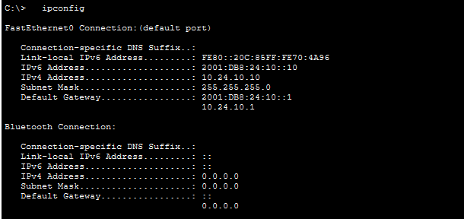
Figure 8: Office-PC1 ipconfig
I used /30 subnets for the router links because a /30 has exactly 2 usable addresses, enough for the two ends of the link, so no addresses are wasted. IPv4 and IPv6 are separate address systems, so IPv6 needs its own prefix. I used 2001:DB8:24::/48 because a /48 has room for many /64 subnets, one for each VLAN and router link. I used the same numbers (10, 20, 30, 40) for the VLAN, the IPv4 third octet and the IPv6 subnet ID. This makes the plan easy to read and to troubleshoot. For example, 10.24.30.0/24 and 2001:DB8:24:30::/64 both belong to VLAN 30.

5. Configuration summary

5.1 CORE-SW
Feature | Configuration
Routing | ip routing and ipv6 unicast-routing enabled
VLAN interfaces | Vlan10, 20, 30, 40, each with an IPv4 and an IPv6 address (section 4.1)
Routed ports | Gi1/0/5 (to Router1) and Gi1/0/6 (to Router2), dual-stack
IPv4 default routes | 0.0.0.0/0 via 10.24.254.2 (AD 1, primary) and via 10.24.254.6 (AD 254, backup)
IPv6 default routes | ::/0 via 2001:DB8:24:F1::2 (AD 1, primary) and via 2001:DB8:24:F2::2 (AD 254, backup)
ACLs | TO-CCTV-BLOCK, FROM-CCTV-BLOCK and their IPv6 versions (section 7)
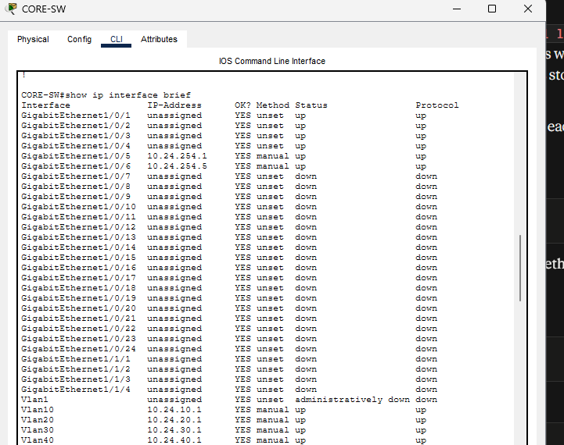
Figure 9: CORE-SW show ip interface brief
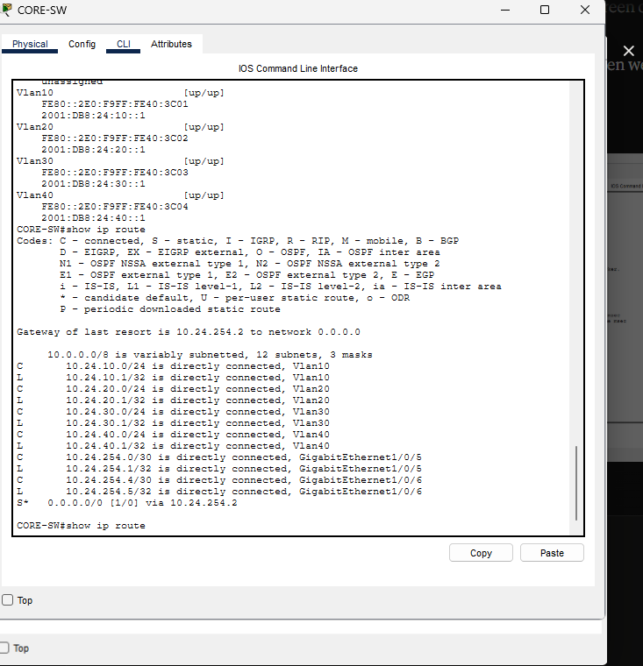
Figure 10: CORE-SW IPv4 routing table
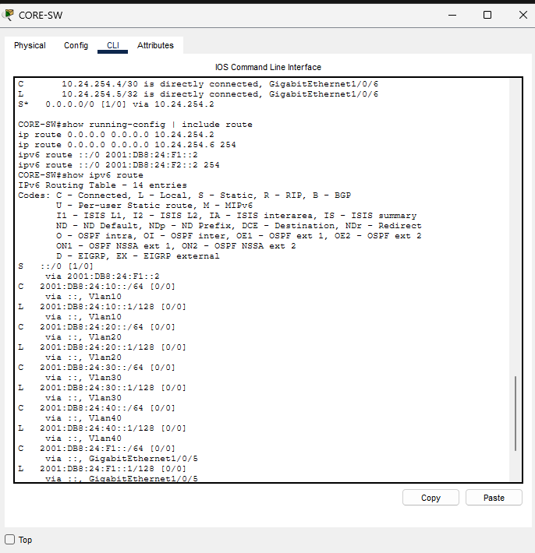
Figure 11: CORE-SW floating routes and IPv6 routes

5.2 Router1 and Router2
Feature | Router1 | Router2
IPv4 default | 0.0.0.0/0 via 203.0.113.2 | 0.0.0.0/0 via 203.0.113.6
IPv4 return route | 10.24.0.0/16 via 10.24.254.1 | 10.24.0.0/16 via 10.24.254.5
IPv6 default | ::/0 via 2001:DB8:FF:1::2 | ::/0 via 2001:DB8:FF:2::2
IPv6 return route | 2001:DB8:24::/48 via 2001:DB8:24:F1::1 | 2001:DB8:24::/48 via 2001:DB8:24:F2::1
IPv4 NAT | PAT (overload) on Gi0/1, access list 1 permits 10.24.0.0 0.0.255.255 | the same on its Gi0/1
IPv6 | Routed, no NAT | Routed, no NAT
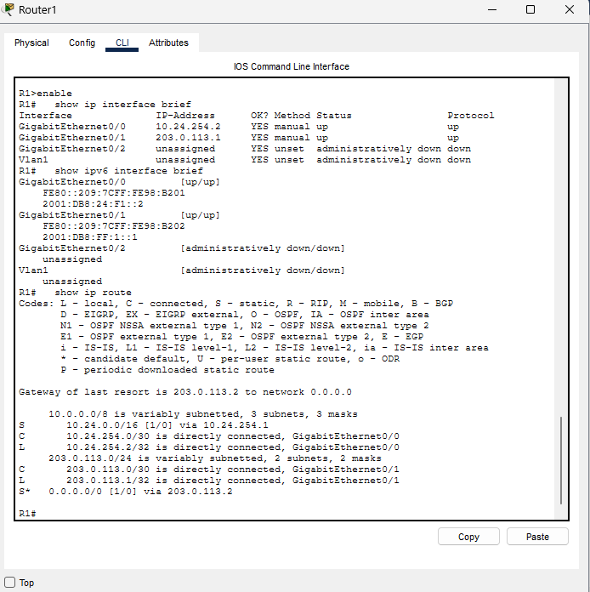
Figure 12: Router1 interfaces and routes
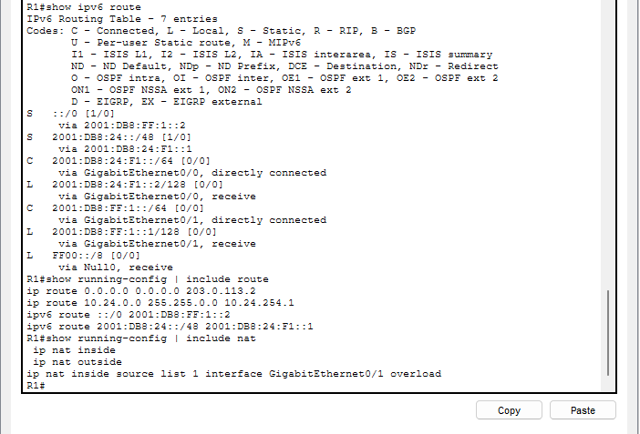
Figure 13: Router1 IPv6 routes and NAT
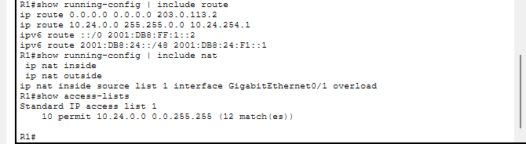
Figure 14: Router1 NAT access list
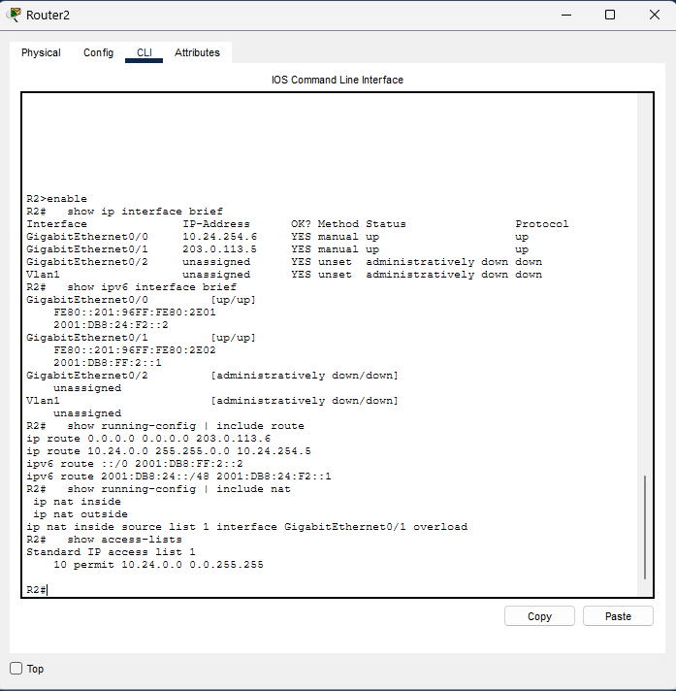
Figure 15: Router2 configuration
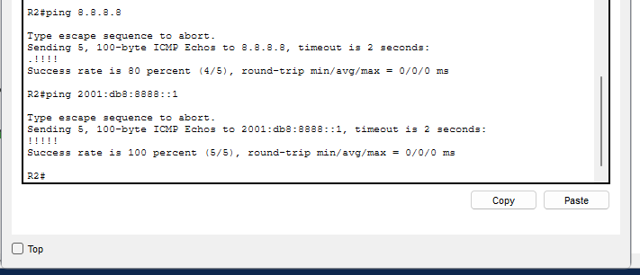
Figure 16: Router2 pings to the Internet test addresses (IPv4 and IPv6)
IPv4 needs PAT because the network uses private addresses (10.24.x.x), which cannot be routed on the Internet, so PAT lets many hosts share one public address. IPv6 does not need it because it has enough addresses to be routed without translation. Each router needs a return route because it is not directly connected to the VLAN subnets. Without a route back through CORE-SW, replies from the Internet would be dropped.

6. IPv6 dual-stack (assigned challenge)
Dual-stack means that devices and network interfaces use IPv4 and IPv6 at the same time. On CORE-SW I turned on IPv6 routing with ipv6 unicast-routing and gave every VLAN interface and both router links an IPv6 address. I added static IPv6 default routes on CORE-SW (a main route through Router1 and a floating backup through Router2). I also added IPv6 return routes on both routers. This suits Kgalagadi Transport Solutions because their old devices still use IPv4, and they can move to IPv6 later without rebuilding the network. I checked it with show ipv6 interface brief and show ipv6 route on CORE-SW. I also pinged the server (2001:DB8:24:40::10) and 2001:db8:8888::1 from Office-PC1, and used tracert to see the path through 2001:DB8:24:F1::2.
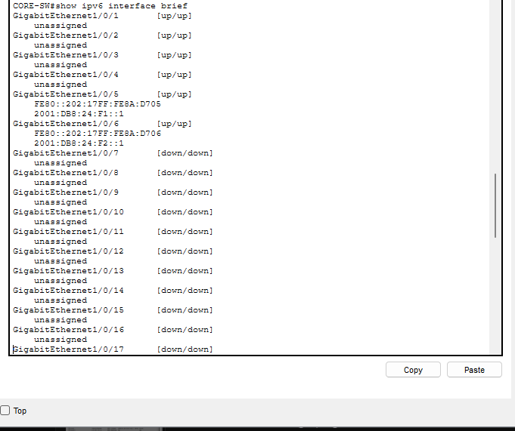
Figure 17: CORE-SW show ipv6 interface brief (part 1)
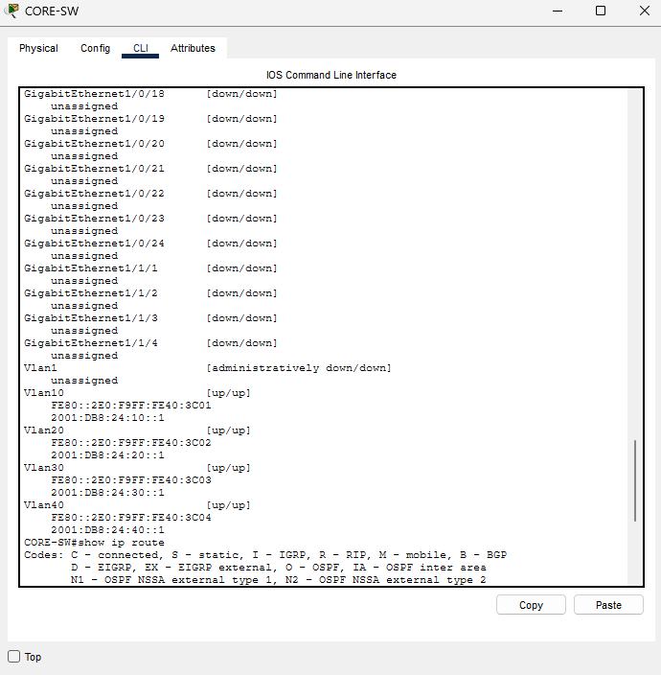
Figure 18: CORE-SW show ipv6 interface brief (part 2)
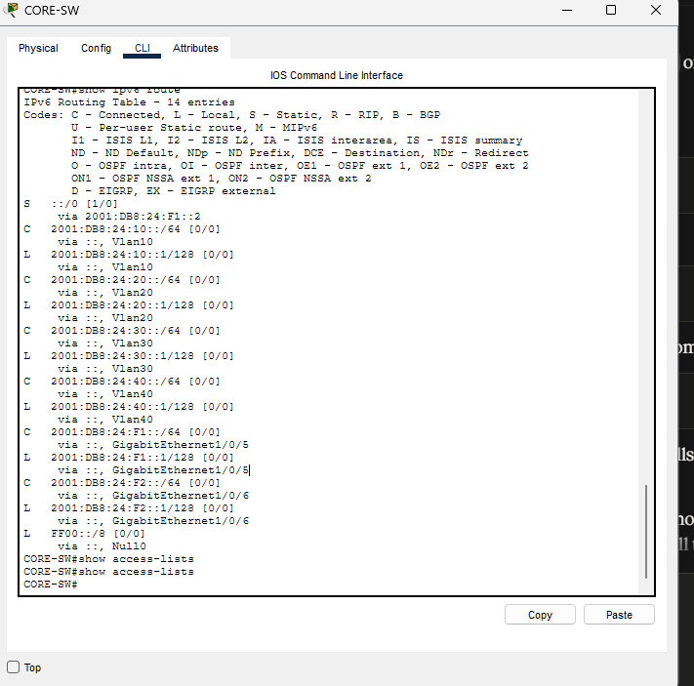
Figure 19: CORE-SW show ipv6 route
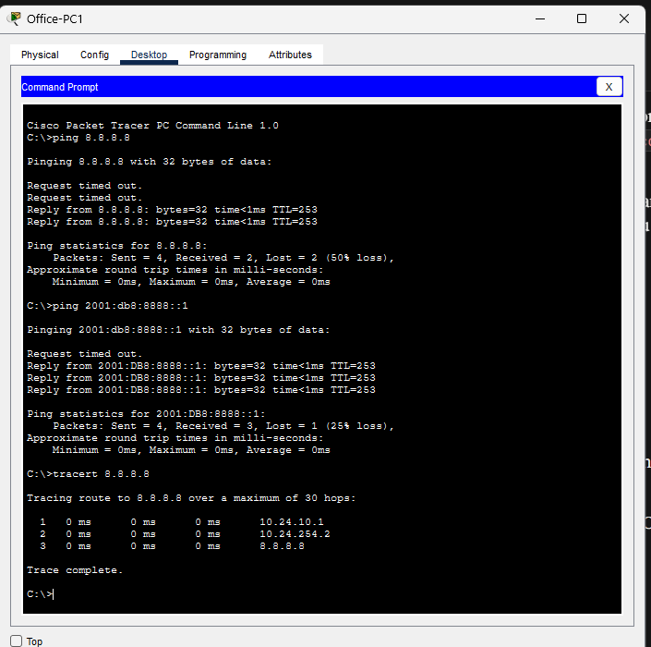
Figure 20: Office-PC1 ping and tracert to the Internet test addresses (IPv4 and IPv6)

7. CCTV segmentation (design constraint)

7.1 Design
CCTV devices sit in VLAN 30 (10.24.30.0/24 and 2001:DB8:24:30::/64). Inbound ACLs on the VLAN interfaces block traffic between the CCTV VLAN and the Office and Logistics VLANs, for IPv4 and IPv6. All other traffic is permitted so the server and Internet access still work.
ACL | Applied to | Rules
TO-CCTV-BLOCK (IPv4) | Vlan10 and Vlan20, inbound | deny 10.24.10.0/24 to 10.24.30.0/24; deny 10.24.20.0/24 to 10.24.30.0/24; permit ip any any
FROM-CCTV-BLOCK (IPv4) | Vlan30, inbound | deny 10.24.30.0/24 to 10.24.10.0/24; deny 10.24.30.0/24 to 10.24.20.0/24; permit ip any any
TO-CCTV-BLOCK-V6 | Vlan10 and Vlan20, inbound | deny 2001:DB8:24:10::/64 and 2001:DB8:24:20::/64 to 2001:DB8:24:30::/64; permit ipv6 any any
FROM-CCTV-BLOCK-V6 | Vlan30, inbound | deny 2001:DB8:24:30::/64 to 2001:DB8:24:10::/64 and 2001:DB8:24:20::/64; permit ipv6 any any
I treated Office VLAN 10 and Logistics VLAN 20 as “office data traffic”, so the ACLs block both of them from reaching the CCTV VLAN. The server VLAN can still reach the cameras because the CCTV rule only blocks Office and Logistics. The server VLAN is not office data traffic, and the cameras need to be managed or recorded from the server.
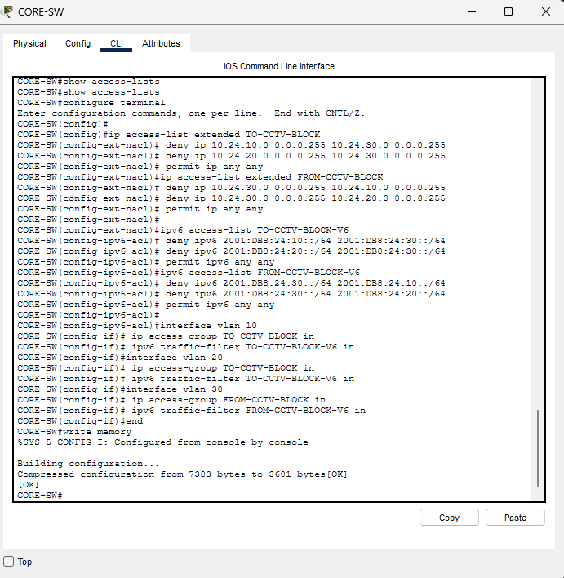
Figure 21: CCTV ACL configuration on CORE-SW
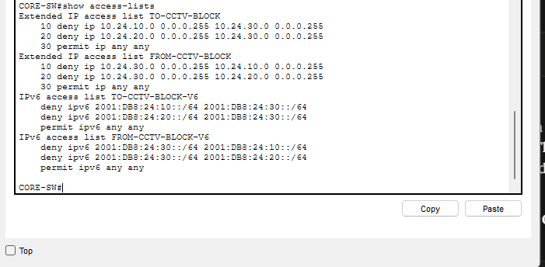
Figure 22: CCTV ACL listing

7.2 Test results
Test | Source | Destination | Result
Blocked | Office-PC1 | CCTV-CAM1, 10.24.30.10 | Destination host unreachable from 10.24.10.1
Blocked | Office-PC1 | CCTV-CAM1, 2001:DB8:24:30::10 | Destination host unreachable from 2001:DB8:24:10::1
Allowed | Office-PC1 | Company-Server, IPv4 and IPv6 | 4 of 4 replies
Allowed | Company-Server | CCTV-CAM1 to 3, IPv4 and IPv6 | 4 of 4 replies
ACL counters | CORE-SW show access-lists | Office deny lines | 8 matches on IPv4 and 8 on IPv6, matching the 8 packets I sent in each protocol
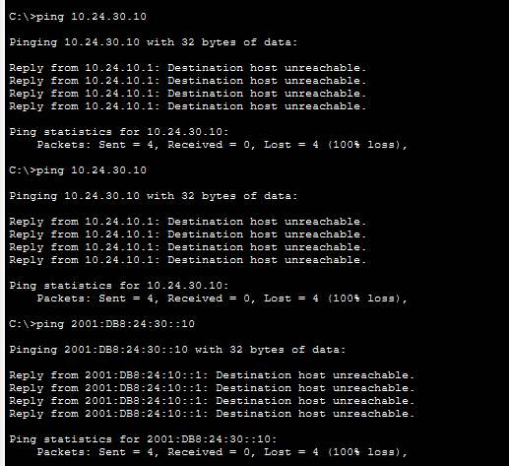
Figure 23: Office-PC1 to CCTV-CAM1 blocked (IPv4)
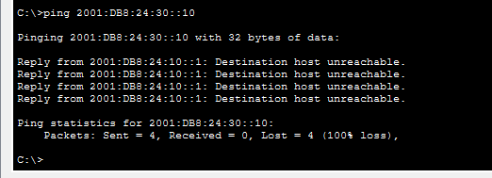
Figure 24: Office-PC1 to CCTV-CAM1 blocked (IPv6)
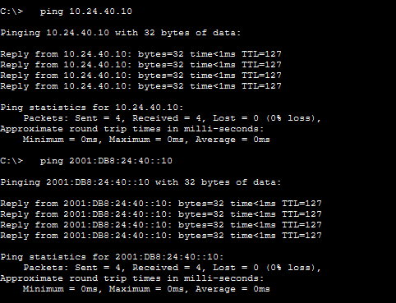
Figure 25: Office-PC1 to Company-Server allowed (IPv4 and IPv6)
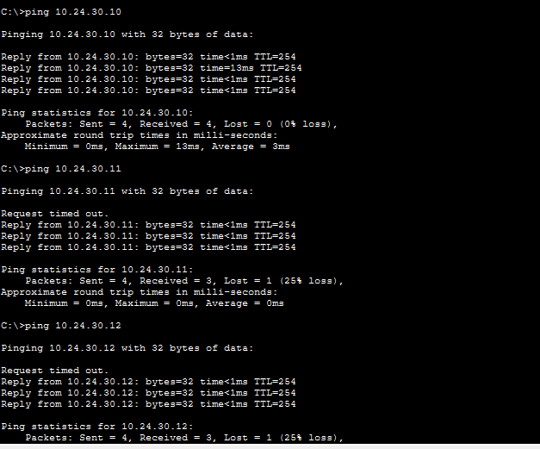
Figure 26: Company-Server pings to the cameras (IPv4)
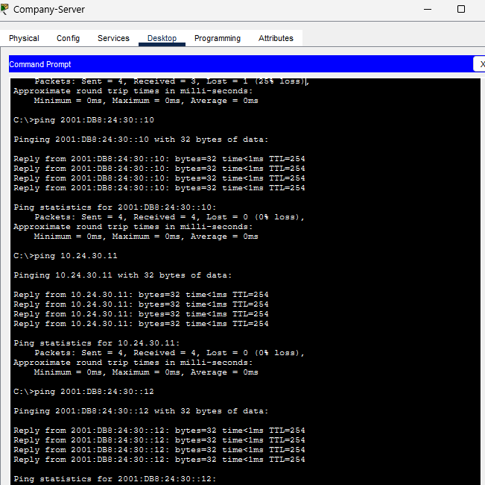
Figure 27: Company-Server pings to the cameras (IPv6)
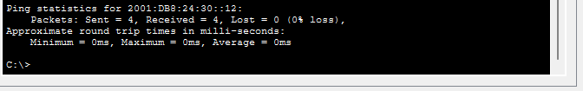
Figure 28: Company-Server pings to the cameras (IPv6, continued)
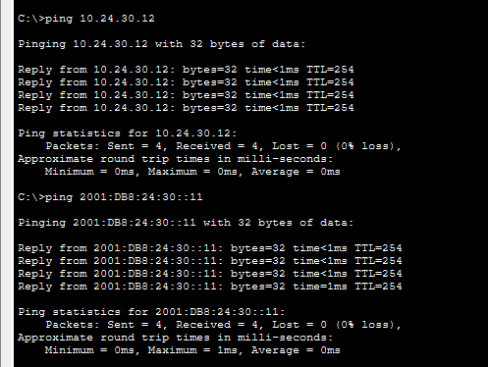
Figure 29: Company-Server pings to CAM3 (IPv4) and CAM2 (IPv6)
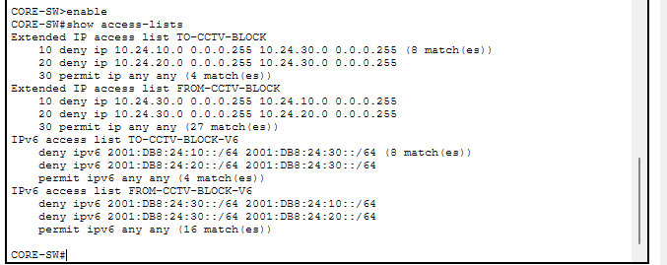
Figure 30: ACL match counts on CORE-SW
I placed the ACLs inbound on the VLAN interfaces so that blocked traffic is stopped at the first interface it enters. It never travels further through the core switch. I filtered both directions because a camera could also start traffic towards the Office and Logistics VLANs, not only the other way round. I filtered both IPv4 and IPv6 because the network is dual-stack, and IPv6 traffic would bypass rules that only cover IPv4. I added permit ip any any at the end because every ACL has a hidden deny at the end. Without it, the server and Internet traffic would also be blocked. The deny lines block only the Office and Logistics traffic to the cameras, and the final permit allows everything else.

8. CR15: second Internet connection

8.1 Design
Router2 and ISP2 provide a second Internet path. The core has two default routes for each protocol. The primary has the default administrative distance of 1. The backup is a floating static route with administrative distance 254, so it is only installed when the primary route disappears.

8.2 Failover test
Stage | What I did | Result
Before | tracert from Office-PC1 | IPv4 hop 2 is 10.24.254.2 and IPv6 hop 2 is 2001:DB8:24:F1::2 (Router1)
Failure | Shut CORE-SW Gi1/0/5, the link to Router1 | Interface went administratively down
After | tracert from Office-PC1 | IPv4 hop 2 is 10.24.254.6 and IPv6 hop 2 is 2001:DB8:24:F2::2 (Router2)
Failback | no shutdown on Gi1/0/5 | Default route back to [1/0] via 10.24.254.2 and tracert through Router1 again
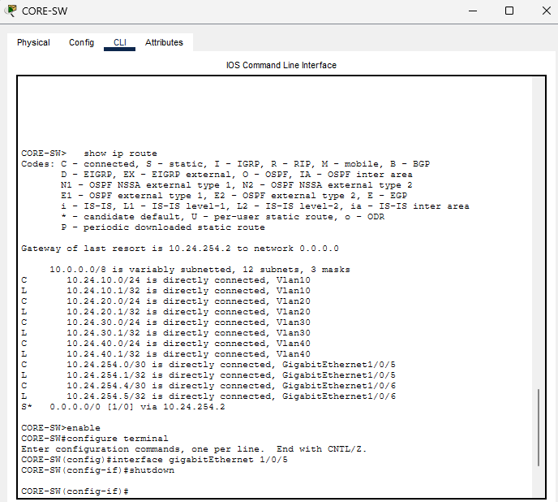
Figure 31: Before failover: CORE-SW default route and shutdown of Gi1/0/5
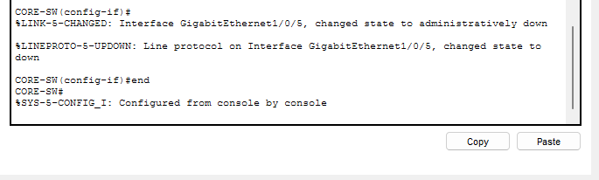
Figure 32: Gi1/0/5 shutdown confirmation
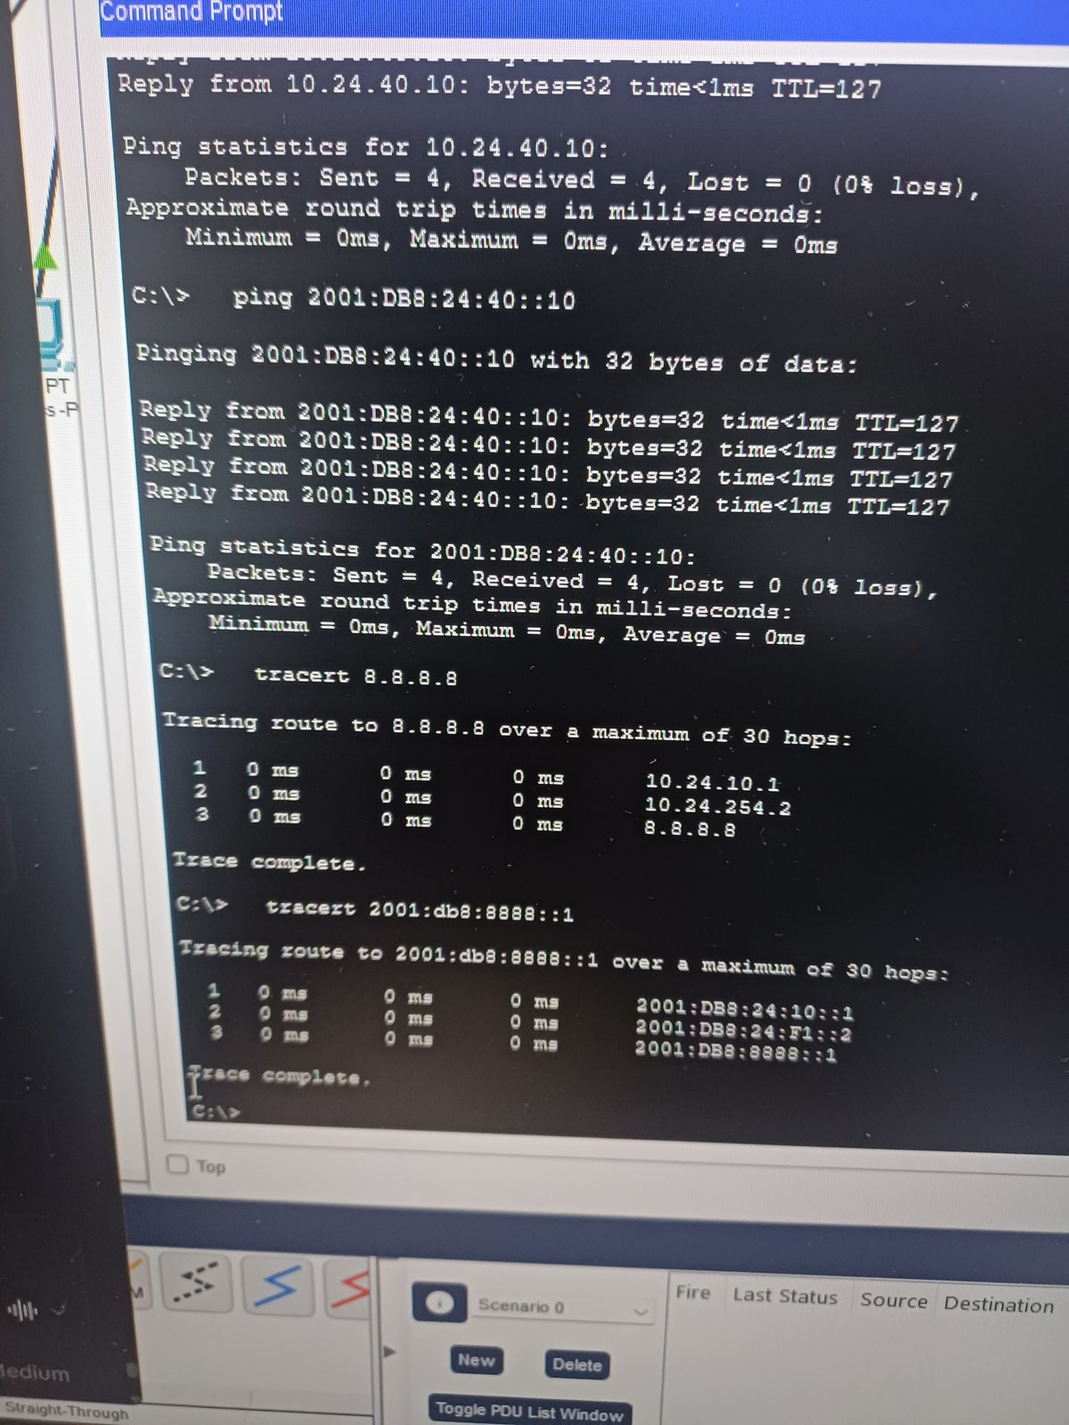
Figure 33: tracert before failover (via Router1)
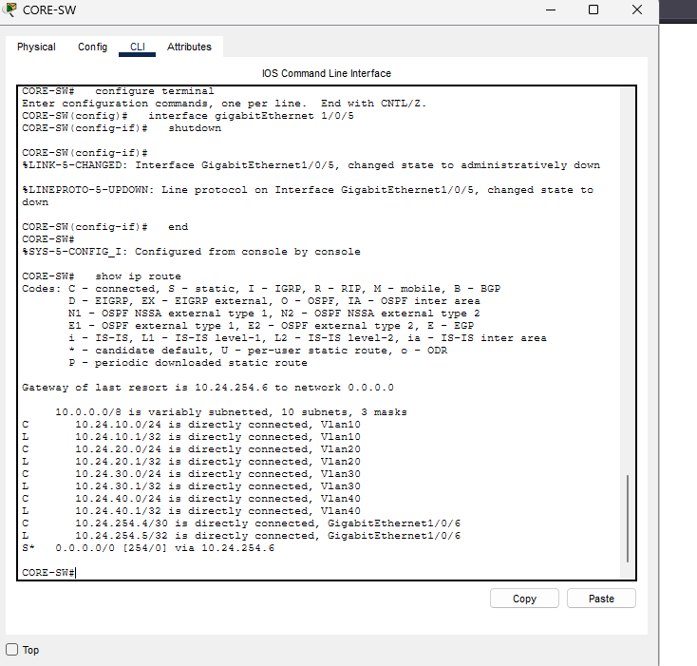
Figure 34: After failure: IPv4 backup route active (via 10.24.254.6)
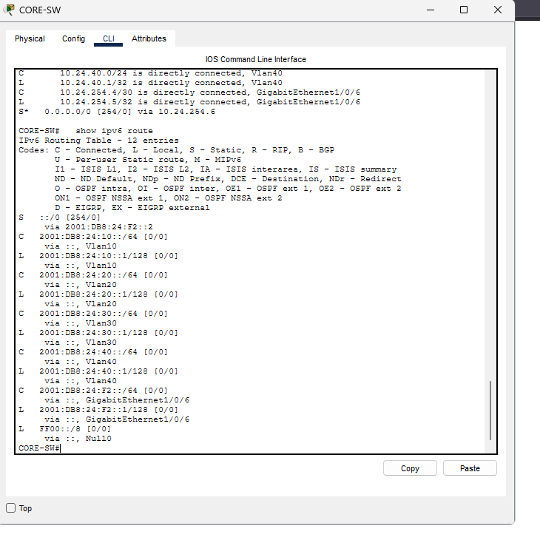
Figure 35: After failure: IPv6 backup route active (via 2001:DB8:24:F2::2)
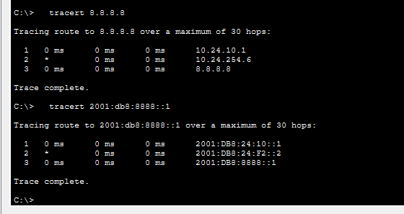
Figure 36: tracert after failover (via Router2)
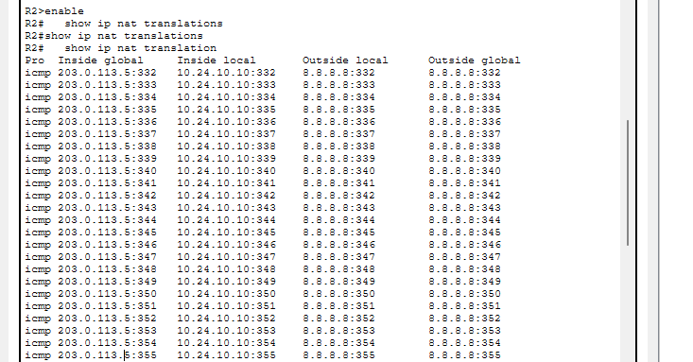
Figure 37: Router2 NAT translations during failover
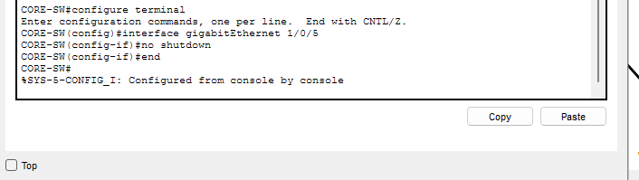
Figure 38: Failback: no shutdown on Gi1/0/5
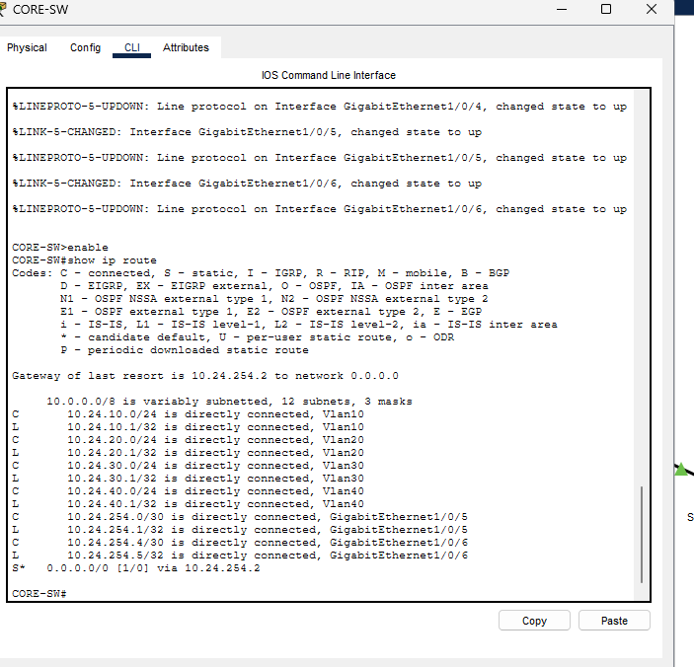
Figure 39: Failback: default route restored via Router1
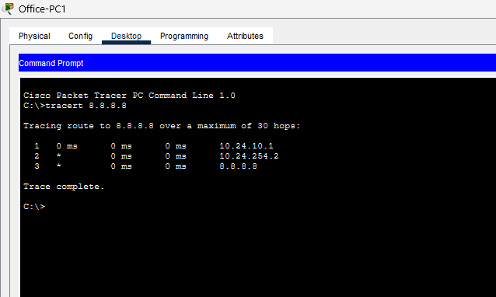
Figure 40: tracert after failback (via Router1)
A floating static route is a backup route with a higher administrative distance (254) than the main route (1). The router prefers the lower distance, so the backup stays unused until the main route disappears. The route changes because when Gi1/0/5 goes down, the next hop through Router1 becomes unreachable. The switch removes the main route and installs the backup route through Router2. This design only reacts when the core switch loses its own link to a router. If only the ISP link fails, the core link stays up, so the core keeps sending traffic to Router1. Route tracking would fix this, but I did not add it because the brief says not to add extra scope.

9. Testing evidence summary
Requirement | Test | Result
End-to-end IPv4 | Office-PC1 to 8.8.8.8 and to 10.24.40.10 | Replies (first packets may be lost to ARP)
End-to-end IPv6 | Office-PC1 to 2001:db8:8888::1 and 2001:DB8:24:40::10 | Replies
Segmentation | Section 7.2 | Blocked and allowed as designed
CR15 | Section 8.2 | Failover and failback proven
Saved configuration | write memory on every device, project saved, closed and reopened | Pings to 8.8.8.8 and 10.24.40.10 worked again, 4 of 4 on the second run
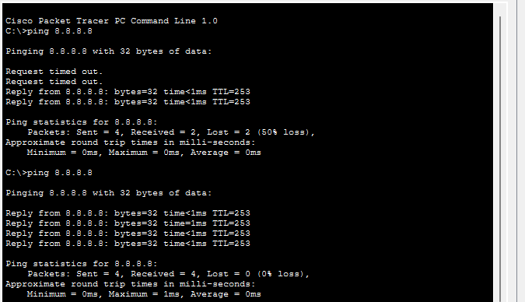
Figure 41: Reopen test: ping to the Internet after reopening the .pkt
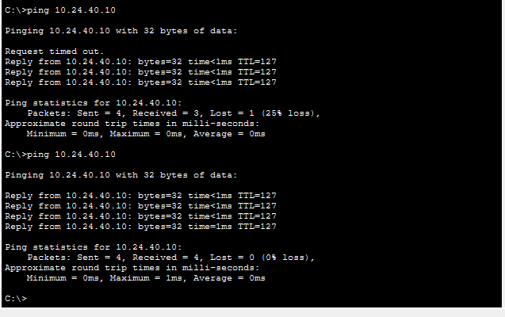
Figure 42: Reopen test: ping to the server after reopening the .pkt

10. Troubleshooting
Problem | What I observed | Cause | Fix
Company-Server could not ping CCTV-CAM1 | 100% loss, but the core could ping the camera 5/5 | The camera had no default gateway saved, so it could not reply to another VLAN | Set Static gateways 10.24.30.1 and 2001:DB8:24:30::1 on the camera's Settings page for GigabitEthernet3, then repeated on CAM2 and CAM3
Camera settings looked unchanged | Settings page showed DHCP | The page was showing the Wireless0 interface, not GigabitEthernet3 | Selected GigabitEthernet3 in the Interfaces dropdown
Wrong value entered | The gateway address was typed into the camera's own address field | Mixed up the interface page and the Settings page | Restored the camera's own address (.10, ::10) and entered the gateway on the Settings page
First pings showed packet loss | 25 to 50% loss on first runs | ARP and IPv6 neighbour discovery delay | Repeated the ping; second run was 0% loss
Company-Server could not ping CCTV-CAM1. I saw 100% loss from the server, yet the core switch could ping the camera 5/5. That showed the camera was reachable inside VLAN 30, the VLAN interfaces were working and the ACLs allowed the server, so the problem had to be the return path. The camera had no default gateway, so it could not send replies to another subnet. I learned that a device can look healthy on its own VLAN and still fail across VLANs when its gateway is missing.
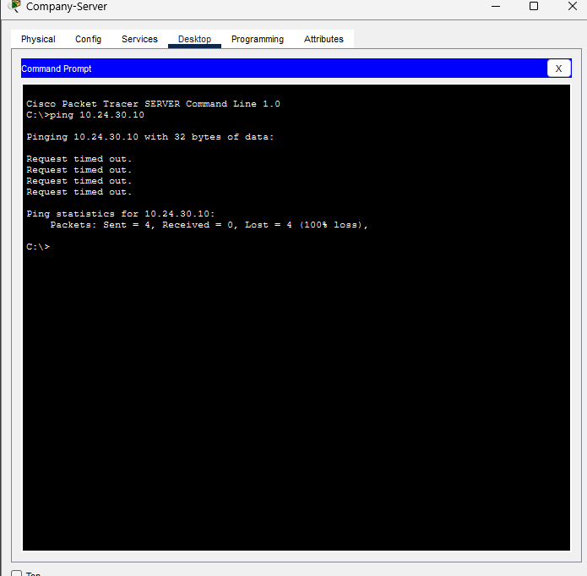
Figure 43: Company-Server ping to the camera failed
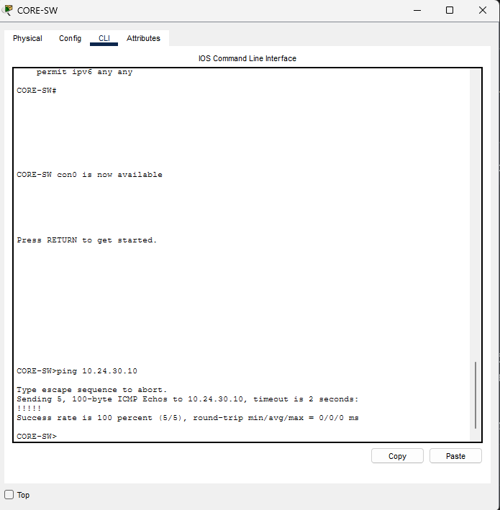
Figure 44: CORE-SW ping to the camera succeeded
Camera settings looked unchanged. After I entered the gateway the page still showed DHCP, so I thought the change had not saved. I then noticed the Interfaces dropdown was set to Wireless0, not GigabitEthernet3, which is the wired port the camera uses. Selecting the correct interface showed the right settings. I learned to check which interface I am editing before assuming a change failed.
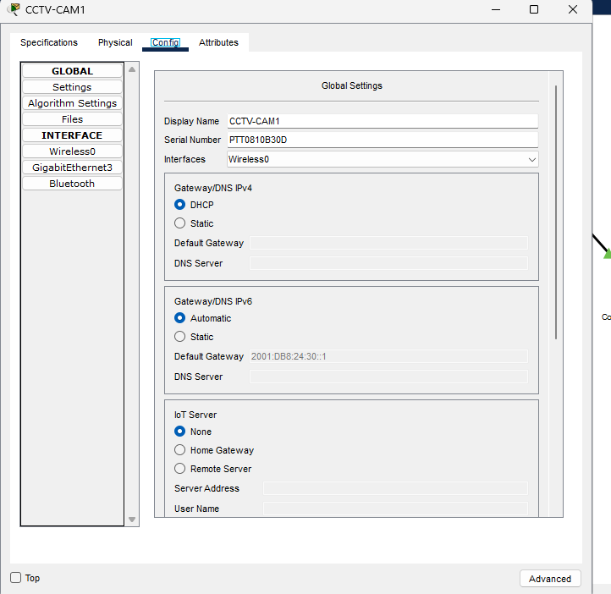
Figure 45: Camera page showing Wireless0 with DHCP
Wrong value entered. I had typed the gateway into the camera's own address field, which changed the camera's IP. I noticed because the camera no longer matched my addressing plan (.10 and ::10) and stopped responding as expected. I restored the camera's own addresses on the interface page and entered the gateways on the Settings page. I learned to keep the two pages separate and to compare each device against my addressing table after changing it.
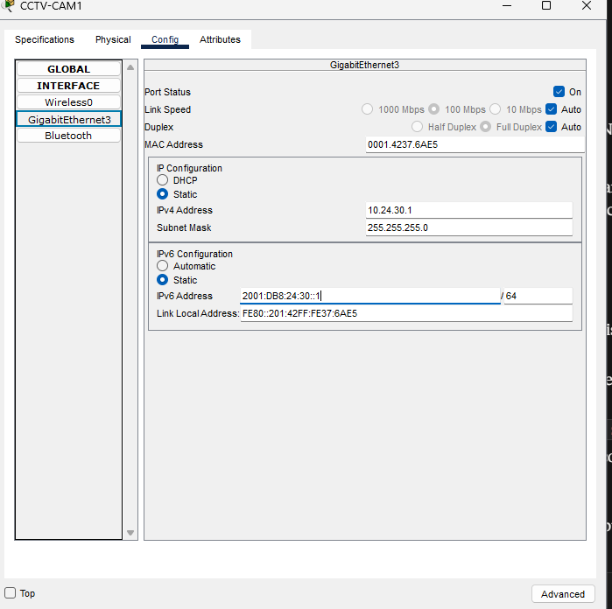
Figure 46: Gateway typed into the camera address field by mistake
First pings showed packet loss. I saw 25 to 50% loss on the first runs but 0% on the second. Because the loss disappeared on its own and only affected the first packets, I concluded it was not a configuration fault. The delay comes from ARP in IPv4 and neighbour discovery in IPv6, which must resolve addresses before traffic flows. I learned to repeat a test before assuming something is broken and to report first-run loss honestly in my evidence.

11. Reflection
The hardest part was the troubleshooting between the server and the cameras, because the core could reach the camera while the server could not. It taught me to work out which direction of the traffic was failing. If I did the project again, I would write down every device's gateway and settings before testing, so I would not have to find mistakes one at a time. I learned that IPv6 follows the same logic as IPv4 but needs its own prefixes, routes and ACLs, and that an ACL covering only IPv4 would leave a dual-stack network open. I also learned that an ACL ends with a hidden deny, so the final permit line is essential for the server and Internet traffic. The ACL match counters were a useful way to prove that the rules blocked exactly the 8 packets I sent. On failover, I learned that a floating static route with a higher administrative distance stays unused until the main route disappears, but my design only reacts when the core's own link to a router fails, not when the ISP link behind the router fails. Given more time, I would add route tracking so the core can detect an ISP failure, and I would add DHCP and more detailed security rules.

12. Appendix
- GitHub portfolio link: https://github.com/wananimanaga1-sketch/CMPG325-2026-044
- Files submitted: .pkt file, this report, GitHub link, video

